NETFLIX SQL PROJECT
- What is the total number of 'Movies' and 'TV Shows' on Netflix?

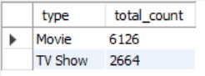
- Which country has produced the most content (Movies + TV Shows) on Netflix? List the top 5 countries.

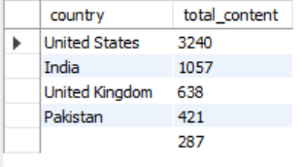
- Retrieve a list of all movies and TV shows released in the year 2020.

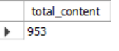

- What are the titles of all movies directed by 'Kirsten Johnson'?
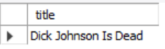

- Which content rating is the most common on Netflix? (Count of titles by rating).

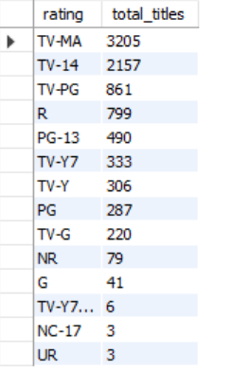
- Find the list of all 'TV Shows' that have 5 or more seasons.

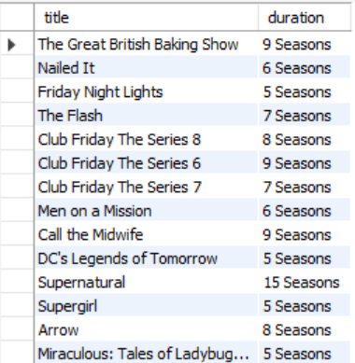
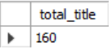

- List all the movies produced in 'India' that belong to the 'Comedies' category.

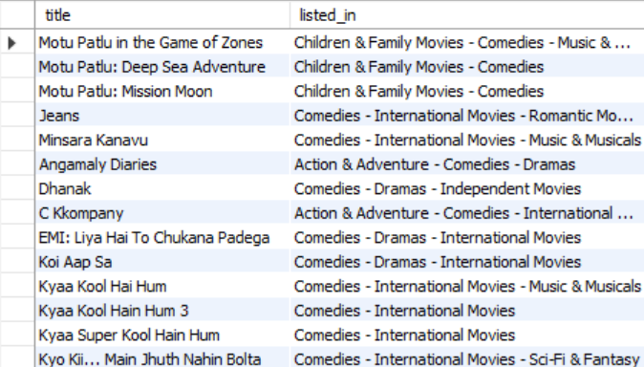
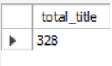

- How many new shows/movies were released each year? Sort the results in descending order of the release year.
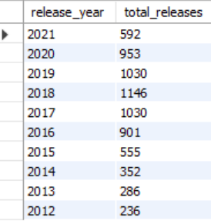

- Who are the top 5 directors with the highest number of directed movies (excluding 'Not Given')?
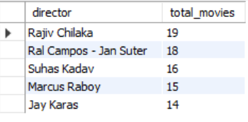
- In which year did Netflix add the highest amount of content to its platform?


- Which are the 5 oldest movies released in India on Netflix?

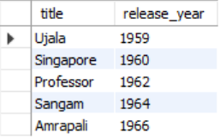

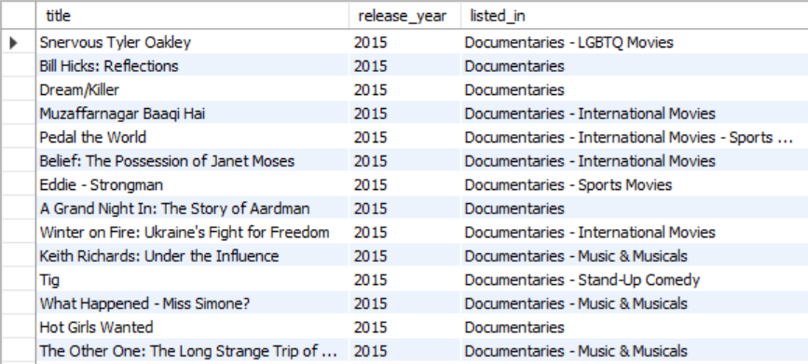
- Find the titles of all movies listed as 'Documentaries' that were released after the year 2015.

- Which movie has the longest duration in minutes on Netflix?


- What is the most recently released movie for each country?

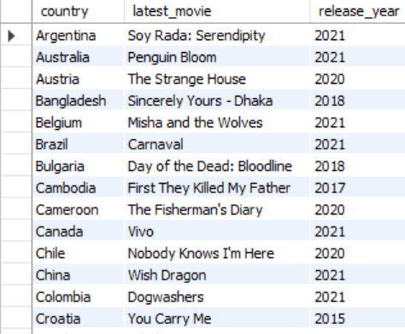

- Identify the release years in which more than 50 movies from India were released.
